**CSS A1 Assignment –by K Jyothi Gangarsha**

**Q1.**

<!DOCTYPE html>

<html lang="en">

<head>

    <meta charset="UTF-8">

    <meta http-equiv="X-UA-Compatible" content="IE=edge">

    <meta name="viewport" content="width=device-width, initial-scale=1.0">

    <title>q1</title>

    <style>

        h1{

            background-color:cornflowerblue;

        }

        div{

            background-color:gray;

        }

        p{

            background-color:lightblue;

        }

    </style>

</head>

<body style="background-color: lightblue;">

    <fieldset>

        <h1>CSS background-color example!</h1>

        <div>

            This is a text inside a div element.

        </div>

        <p>This paragraph has its own background color.</p>

        <div>

            We are still in the div element.

        </div>

    </fieldset>

</body>

</html>

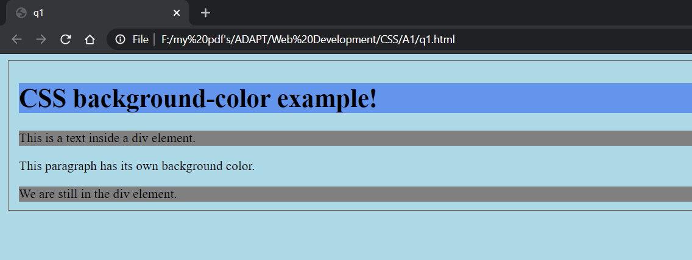

Q2.

<!DOCTYPE html>

<html lang="en">

<head>

    <meta charset="UTF-8">

    <meta http-equiv="X-UA-Compatible" content="IE=edge">

    <meta name="viewport" content="width=device-width, initial-scale=1.0">

    <title>q2</title>

    <style>

        body{

            background-color: lightblue;

        }

    </style>

</head>

<body>

    <fieldset>

        <div>

            <h1>This is heading 1</h1><br>

            <strike><h2>This is heading 2</h2></strike><br>

            <u><h3>This is heading 3</h3></u><br>

            <h4>This is heading 4</h4><br>

        </div>

    </fieldset>

</body>

</html>

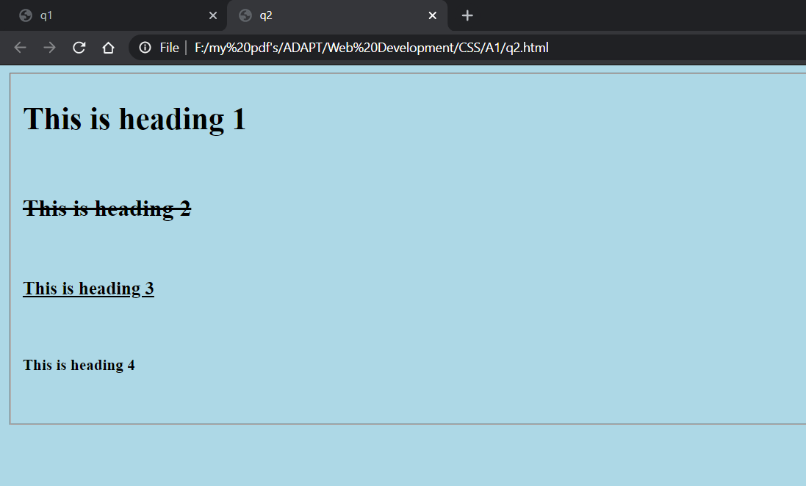

Q3.

<!DOCTYPE html>

<html lang="en">

<head>

    <meta charset="UTF-8">

    <meta http-equiv="X-UA-Compatible" content="IE=edge">

    <meta name="viewport" content="width=device-width, initial-scale=1.0">

    <title>q3</title>

    <style>

        body{

            background-color: lightblue;

        }

    </style>

</head>

<body>

    <fieldset>

        <div>

            <h3>THIS IS SOME TEXT.</h3>

            <h4>This is some text.</h4>

            <h4>This is some text.</h4>

        </div>

    </fieldset>

</body>

</html>

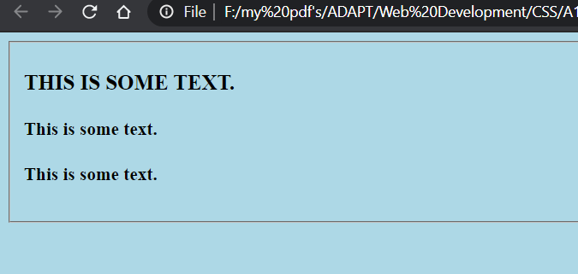

Q4.

<!DOCTYPE html>

<html lang="en">

<head>

    <meta charset="UTF-8">

    <meta http-equiv="X-UA-Compatible" content="IE=edge">

    <meta name="viewport" content="width=device-width, initial-scale=1.0">

    <title>q4</title>

    <style>

        fieldset{

            background-color: lightblue;

        }

        a{

            color: red;

        }

    </style>

</head>

<body>

    <fieldset>

        <a href="http://www.spring.io">This is a link</a>

    </fieldset>

</body>

</html>

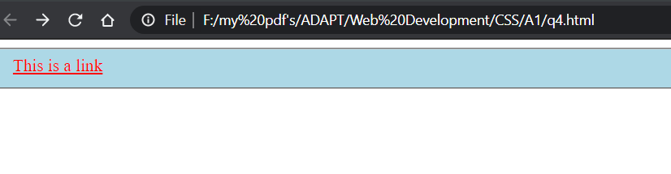Q5.

<!DOCTYPE html>

<html lang="en">

<head>

    <meta charset="UTF-8">

    <meta http-equiv="X-UA-Compatible" content="IE=edge">

    <meta name="viewport" content="width=device-width, initial-scale=1.0">

    <title>q5</title>

    <style>

        table{

            width: 10px

            }

            th{

            text-align: left;

            }

            table, th, td {

            border: 2px solid #000;

            border-collapse: collapse;

            }

        </style>

</head>

<body>

    <fieldset>

        <table>

            <tr>

                <th>Firstname:</th>

                <th>Lastname:</th>

            </tr>

            <tr>

            <td>Peter</td>

            <td>Griffin</td>

            </tr>

            <tr>

                <td>Lois</td>

                <td>Griffin</td>

            </tr>

        </table>

        </fieldset>

</body>

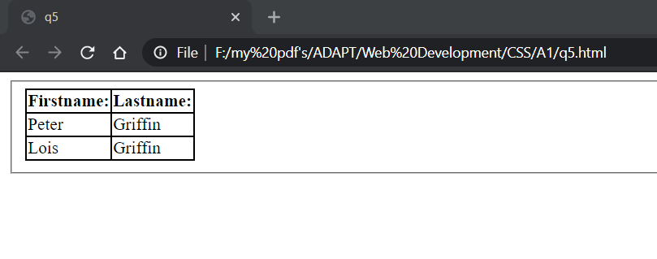</html>

Q6.

<!DOCTYPE html>

<html lang="en">

<head>

    <meta charset="UTF-8">

    <meta http-equiv="X-UA-Compatible" content="IE=edge">

    <meta name="viewport" content="width=device-width, initial-scale=1.0">

    <title>q6</title>

    <style>

        th{

        background-color: Green;

        color: white;

        }

        table, th, td{

        border:2px solid green;

        }

    </style>

</head>

<body>

    <fieldset>

        <table>

            <tr>

                <th>Firstname</th>

                <th>Lastname</th>

                <th>Savings</th>

            </tr>

            <tr>

            <td>Peter</td>

            <td>Griffin</td>

            <td>&100</td>

            </tr>

            <tr>

                <td>Lois</td>

                <td>Griffin</td>

                <td>&150</td>

            </tr>

            <tr>

                <td>Joe</td>

                <td>Swanson</td>

                <td>&300</td>

            </tr>

            <tr>

                <td>Cleveland</td>

                <td>Brown</td>

                <td>&250</td>

            </tr>

        </table>

        </fieldset>

</body>

</html>

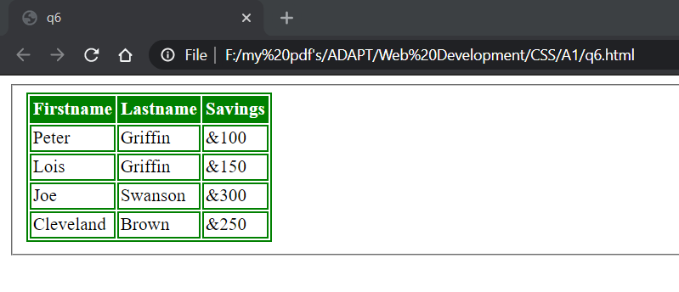

Q7.

<!DOCTYPE html>

<html lang="en">

<head>

    <meta charset="UTF-8">

    <meta http-equiv="X-UA-Compatible" content="IE=edge">

    <meta name="viewport" content="width=device-width, initial-scale=1.0">

    <title>q7</title>

    <style>

        h1{

        border: 3px solid red;

        margin-top: 0;

        margin-bottom: 0;

        width: 890px;

        }

        div{

            border:5px dotted #86E307;

            width: 890px

        }

        </style>

</head>

<body>

    <div>

        <h1>IE8 supports the outline properties only if a !DOCTYPE is specified</h1>

    </div>

</body>

</html>

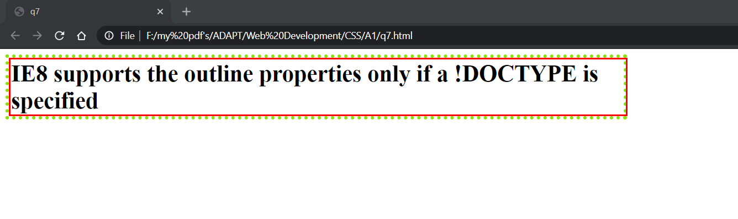

Q8.

<!DOCTYPE html>

<html lang="en">

<head>

    <meta charset="UTF-8">

    <meta http-equiv="X-UA-Compatible" content="IE=edge">

    <meta name="viewport" content="width=device-width, initial-scale=1.0">

    <title>q8</title>

    <style>

        h3{

        background-color: #AED6F1;

        border: 10px solid black;

        margin-bottom: 3px;

        }

        h4{

        background-color: #AED6F1;

        border: 5px solid black;

        margin-bottom: 3px;

        }

        p{

        background-color: #AED6F1;

        border: 1px solid black;

        margin-bottom: 3px;

        }

    </style>

</head>

<body>

    <fieldset>

        <h3>Some Text.</h3>

        <br>

        <h4>Some Text.</h4>

        <br>

        <p>Some Text.</p>

        <br>

        </fieldset>

</body>

</html>

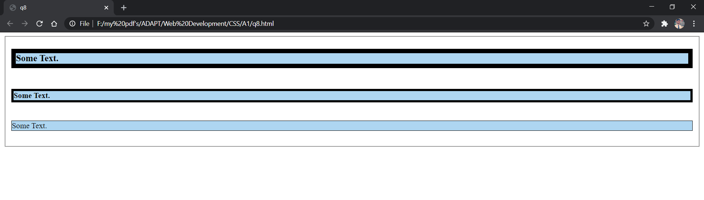

---Thankyou---